LS :
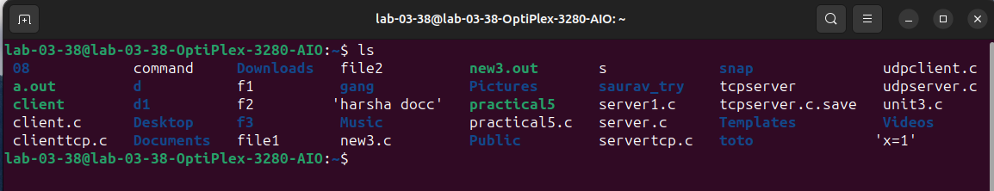

MAN LS:
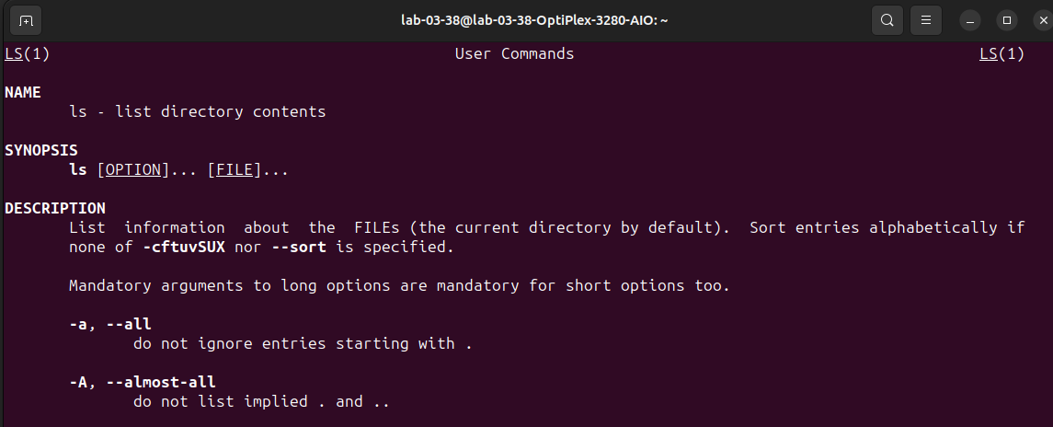

MKDIR:
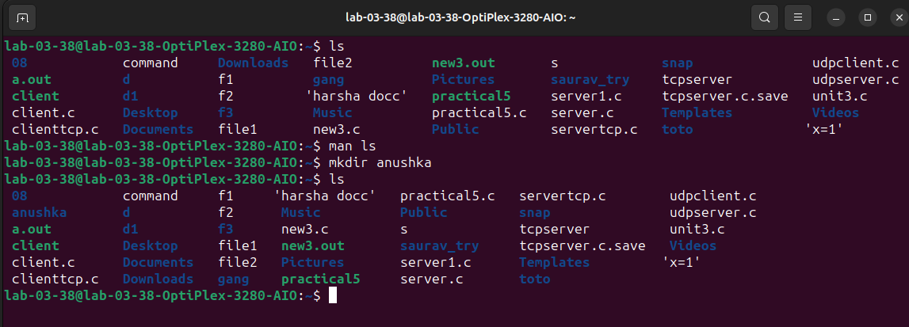

RMDIR:
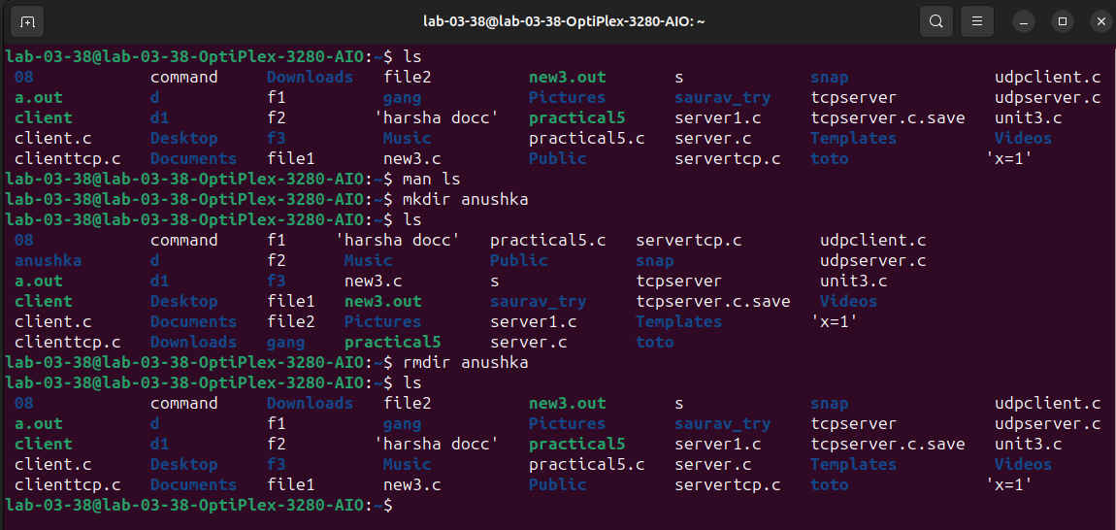
PWD:

CD:
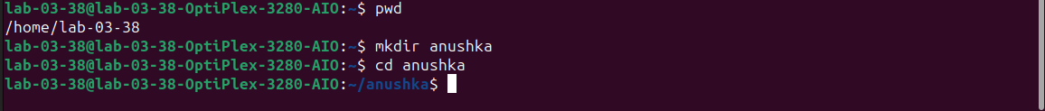
CD - :
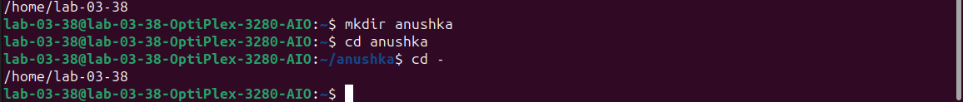
RM:
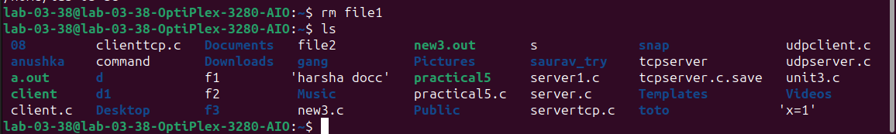

TOUCH:
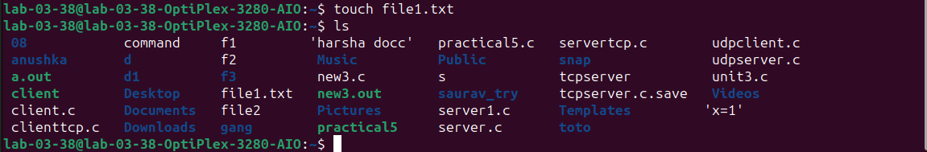
MV:
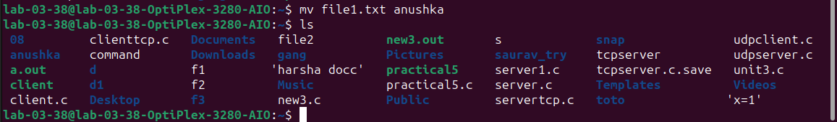
CAT:
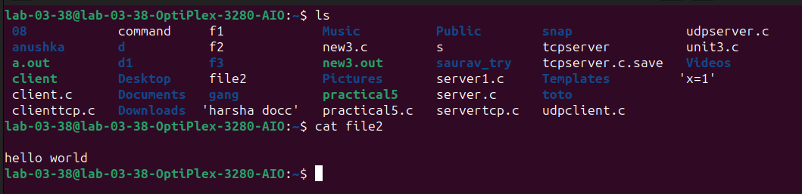
UNAME:
PS:
